7103 Peter Wong Spring 2022 SoA UNCCharlotte
7102

Saccade Space: design with an eye toward the tiny

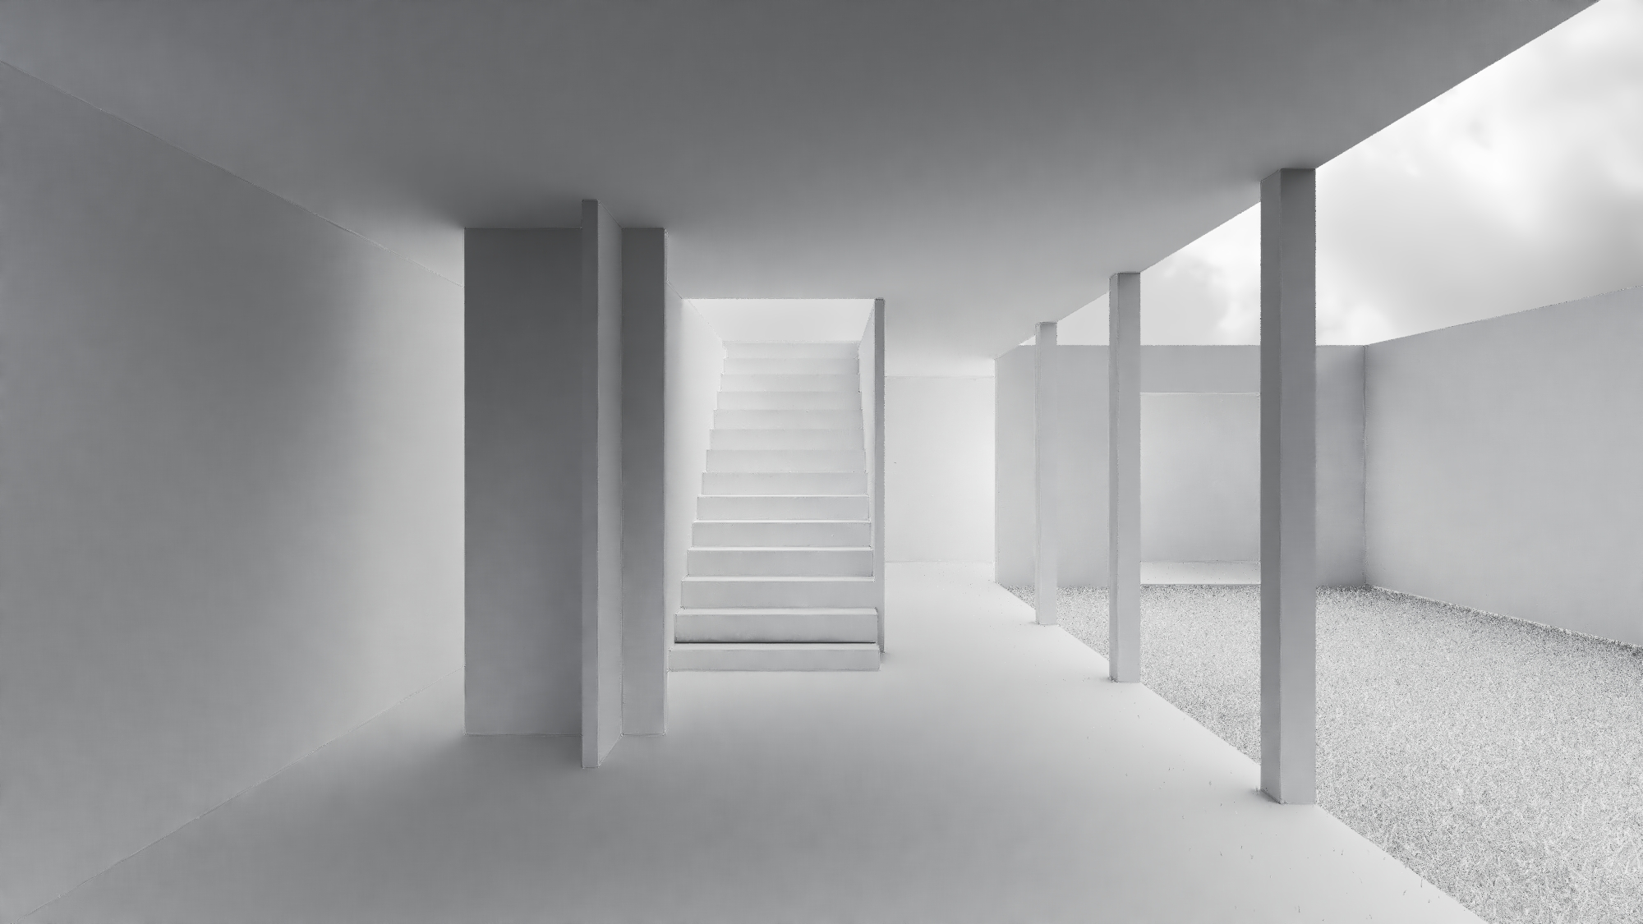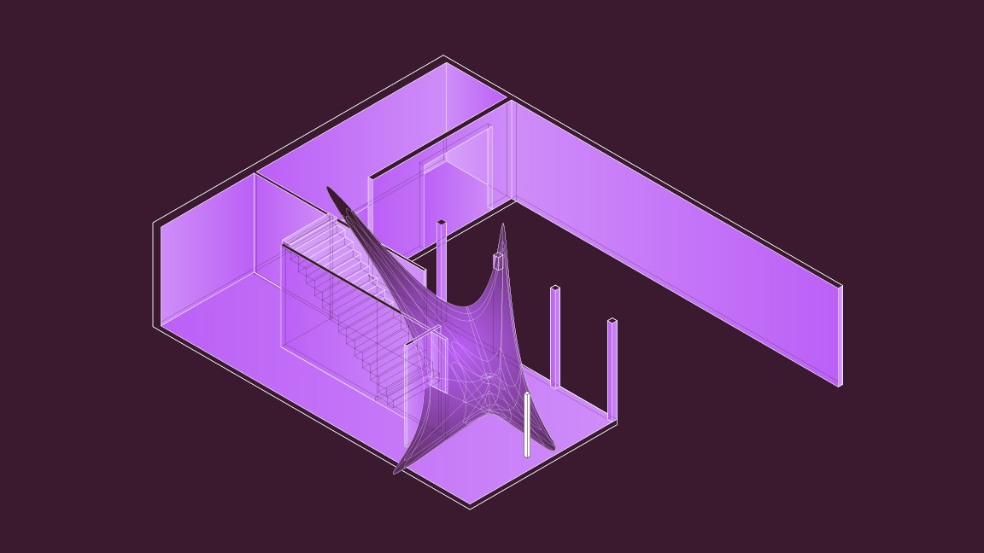
Movement of the eye shown as in an indeterminate architectural space (image by B. Simmons).

All great and beautiful work has come of first gazing without shrinking into the darkness.

-John Ruskin

Course Info
7102-002 | Grad Topics Studio | Sp 2022 | MW F 2:00-5:15p | prerequisite 7101 | Peter Wong | online | plwong@uncc.edu

Premise
Architecture is full of camps. Form, space, and composition rule for the artistic architect, sustainable solutions are championed by the environmental designer, socially-responsible leaders speak of equity and design activism, and the digital crowd find power in data and the promise of automated form. Of course, there are many more orientations for design that architects might align themselves with, in the end it becomes confusing to know which path is most important, which one to follow. Simultaneously, there are designers, such as Michael Meredith of MOS, that speak of a position of indifference, a denial of sorts to join any particular camp, a flinch that resists excluding all possibilities. This studio begins with a premise that design is a web of concerns that privileges no one attribute or problem over another.

The studio will start with investigations into the spatial realms of architecture. First it will consider the history and possibilities of perceptual design as an elemental problem of configuration, inhabitation, and systemic reasoning. Next, students will work with contemporary research tools, including eye tracking hardware and software to help understand a system of spatial possibilities. This step will include physical modeling of these spatial types based on the eye tracking data collected from experiments the class will be conducting. Lastly, the class will work with the design of small affordable housing units, creating prototypes for micro housing configurations incorporating the spatial effects gained from their eye tracking research.

Method and Content
The class will be structured as a studio design course. Readings, case studies, and research techniques will comprise the first part of the semester. The remaining part of the class will involve design alternatives and a solution that aims to be comprehensive and holistic, in an attempt to investigate design as research. There will be public presentation events as well as a possible field study for the class (TBA).

Bibliography
Background essays, articles, and chapter readings by the instructor, TBA.

Evaluations / Grading
UNCCharlotte graduate grading scales shall apply. Grade distribution: history of space (10%), eye tracking research (20%), micro-unit (65%), engagement/participation/attendance (5%)

