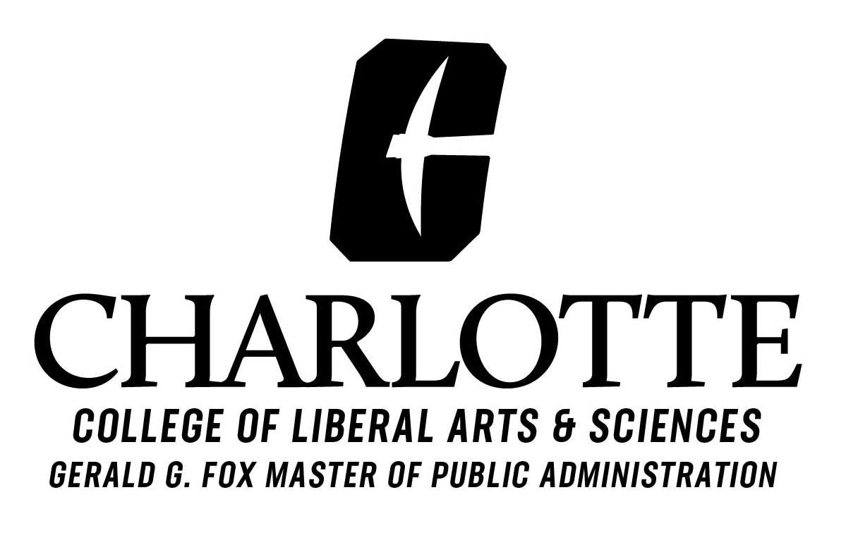

INTERNSHIP EVALUATION BY EMPLOYER

Thank you for your sponsorship of this intern. Please complete this evaluation. The information will be used to help us enhance the MPA Program.

Intern's Name:
Employer Name:

Supervisor's Name:

1) Description of intern's assigned duties:

2) Assessment of intern's performance:

________ Please rate the intern’s performance using the following scale: 1 = poor; 2 = fair; 3 = good; 4= very good

3) Evaluation of intern's preparation for completing assigned duties (may include background, experience, education and degree of professionalism):

________ Please rate the intern’s preparation using the following scale: 1 = poor; 2 = fair; 3 = good; 4= very good

4) Effectiveness of internship role in your organization:

5) Would you be willing to sponsor another intern from UNCC's MPA Program?

